**Full Stack Development with MERN**

**Project Documentation format**

**1. Introduction**

• Project Title: Citizen AI – Intelligent Citizen Engagement Platform

• Team Members:

Team Leader : Gajjala Bala Dinesh Reddy

Team member : Omkaram Manjunath Raju

Team member : Vadde Kavya

Team member : Obu Mahendra

**2. Project Overview**

• Purpose: **Citizen AI** refers to the application of artificial intelligence technologies to enhance civic life by enabling better interaction between citizens and government institutions. It aims to make governance more transparent, participatory, and data-driven. By integrating AI tools like chatbots, predictive analytics, and natural language processing, Citizen AI helps in automating public services, collecting citizen feedback, detecting issues early, and improving policy decisions.

This innovation not only empowers individuals to voice their concerns more effectively but also aids governments in understanding community needs and delivering services more efficiently. Citizen AI is a key component in building smart, inclusive, and accountable cities of the future.

**Features:**

• **AI-Powered Chatbot Assistance**  
Enables 24/7 citizen support for queries related to public services, complaints, and government schemes.

• **Smart Grievance Redressal**  
Automatically categorizes, prioritizes, and routes citizen complaints to the appropriate departments.

• **Real-Time Notifications & Alerts**  
Sends timely updates on civic issues like traffic, water outages, elections, and emergencies.

• **Natural Language Processing (NLP)**  
Understands and responds to citizen queries in regional languages, enhancing accessibility.

• **Sentiment Analysis & Feedback Monitoring**  
Analyzes social media and citizen feedback to identify public mood and service satisfaction.

• **Predictive Analytics**  
Helps local governments forecast urban problems like water shortage, waste overflow, or traffic congestion using historical data.

• **Personalized Citizen Dashboard**  
Offers customized views of services, request statuses, bills, and local announcements.

• **Open Data Visualization**  
Displays civic metrics like budgets, public works, and development projects in easy-to-understand formats.

• **Voice and Text Input Integration**  
Allows both spoken and written interaction for user-friendly access across all age groups.

• **Secure & Scalable Cloud-Based Architecture**  
Ensures data protection and supports large-scale deployment across cities and regions.

**3. Architecture**

• Frontend: Describe the frontend architecture using React.

• Backend: Outline the backend architecture using Node.js and Express.js.

• Database: Detail the database schema and interactions with MongoDB.

**4. Setup Instructions**

• Prerequisites: List software dependencies (e.g., Node.js, MongoDB).

• Installation: Step-by-step guide to clone, install dependencies, and set up the

environment variables.

**5. Folder Structure**

• Client: Describe the structure of the React frontend.

• Server: Explain the organization of the Node.js backend.

**6. Running the Application**

• Provide commands to start the frontend and backend servers locally.

o Frontend: npm start in the client directory.

o Backend: npm start in the server directory.

**7. API Documentation**

• Document all endpoints exposed by the backend.

• Include request methods, parameters, and example responses.

**8. Authentication**

• Explain how authentication and authorization are handled in the project.

• Include details about tokens, sessions, or any other methods used.

**9. User Interface**

• Provide screenshots or GIFs showcasing different UI features.

**10. Testing**

• Describe the testing strategy and tools used.

**11. Screenshots or Demo**

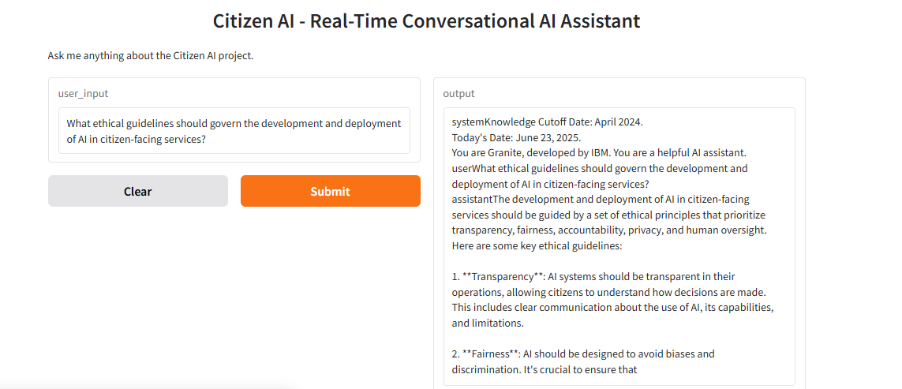

13. Future Enhancements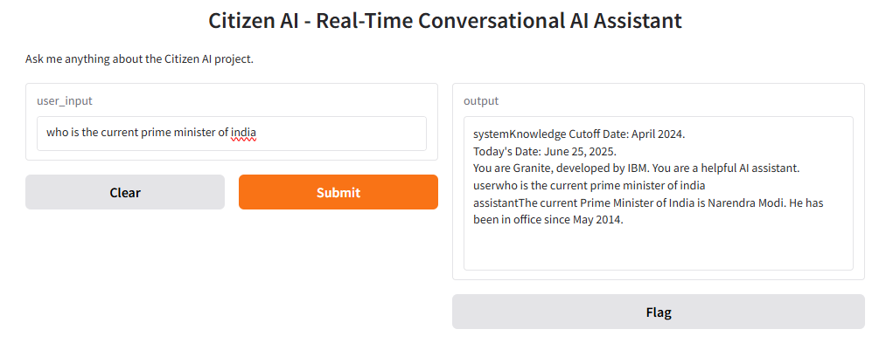

**12. Known Issues**

**•** Document any known bugs or issues that users or developers should be aware of.

**13. Future Enhancements**

1. **Integration with Smart City Infrastructure**
   * Seamless collaboration with IoT devices, sensors, and public services for real-time updates on traffic, pollution, water usage, and more.
2. **Multi-Language and Voice Support**
   * Expanding accessibility through advanced NLP to support regional languages and voice-based interaction, helping rural and non-literate users.
3. **Predictive Governance**
   * Using AI to forecast issues like disease outbreaks, civic complaints, or resource shortages, enabling proactive government action.
4. **AI-Powered Policy Making**
   * Analyzing large-scale citizen feedback and social data to assist policymakers in drafting responsive and effective legislation.
5. **Blockchain Integration for Transparency**
   * Combining AI with blockchain to ensure secure, verifiable, and tamper-proof public records and transactions.
6. **Personalized Civic Services**
   * Delivering tailored information and services (e.g., local events, job alerts, welfare eligibility) based on citizen profiles and behavior.
7. **Adaptive Learning Systems**
   * AI models that continuously learn from user interactions and improve the relevance and accuracy of responses over time.
8. **Disaster Management & Crisis Response**
   * Real-time AI assistance in emergencies by guiding citizens, allocating resources, and coordinating rescue operations.
9. **Global Collaboration and Policy Sharing**
   * Adopting Citizen AI platforms across countries for shared learning, data exchange, and AI ethics standardization.
10. **Fully Autonomous Virtual Assistants for Government**

Future systems may offer complete virtual public servants capable of handling tasks like filing taxes, applying for schemes, or resolving disputes.